**Name –Sandesh Pathak**

**Roll No 65**

**PRN 2014111507**

**Subject STE Practical 3**

**Do-While Loop**

|  |  |  |  |  |  |  |
| --- | --- | --- | --- | --- | --- | --- |
| **Test Scenario ID** | Even Odd-1 | | | Test Case ID | Even-Odd 1A | |
| **Test Case Description** | Even-Odd Using Do -while | | | Test Priority | High | |
| **Pre-Requisite** | Checks whether number is even or odd | | | Post-Requisite | NA | |
|  |  |  |  |  |  |  |
| S.No | Action | Inputs | Expected Output | Actual Output | Test Result |  |
| 1 | Enter the number | Value=2 | 2 is even  3 is odd  4 is even  5 is odd  6 is even | 2 is even  3 is odd  4 is even  5 is odd  6 is even | Pass |  |
| 2 | Enter the number | Value= -2 | -2 is even  -3 is odd  -4 is even  -5 is odd  -6 is even | -2 is an even Number | Fail |  |
| 3 | Enter the Number | Value=1234567891222 | 1234567891222 | 2345678912222 | Fail |  |

**Input :-**

#include<stdio.h>

void main()

{

int i,n=5,j=0;

clrscr();

printf("enter a no:");

scanf("%d",&i);

do

{

if(i%2==0)

{

printf("%d",i);

printf("is an even no");

i++;

j++;

}

else

{

printf("%d",i);

printf("is an odd no");

i++;

j++;

}

}

while(i>0&&j<n);

getch();

}

**Output**

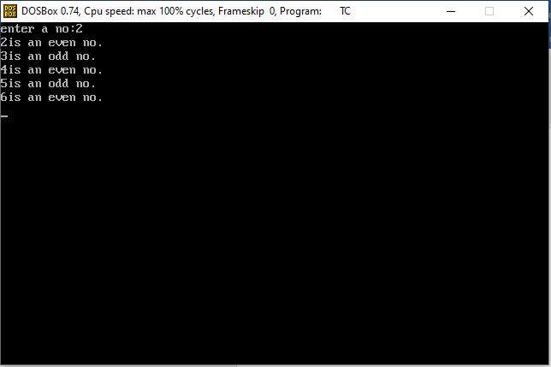

* **Switch Case**

|  |  |  |  |  |  |  |
| --- | --- | --- | --- | --- | --- | --- |
| **Test Scenario ID** | Even Odd-1 | Test Case ID | Even-Odd 1A | | | |
| **Test Case Description** | Even-Odd Using Do -while | Test Priority | High | | | |
| **Pre-Requisite** | Checks whether number is even or odd | Post-Requisite | NA | | | |
|  |  |  |  |  |  |  |
| S.No | Action | Inputs | Expected Output | Actual Output | Test Result |  |
| 1 | Addition of 2 numbers | Enter your choice  1  Enter 1st No :3  2nd number: 3 | Output is 5 | Output is 5 | Pass |  |
| 2 | Subtraction of 2 numbers | Enter your choice  2  Enter 1st No :3  2nd number: 3 | Output is 1 | Output is 1 | Pass |  |
| 3 | Multiplication of 2 numbers | A=22222222222  B=22222222222 | 4444444444444 | -2 | Fail |  |
| 4 | Division of 2 numbers | A=10 and  B=0 | error | error | Fail |  |

**Input**

#include <stdio.h>

void main(){

int ch,num1,num2,result;

do{

system("cls");

printf("1.........Addition\n");

printf("2.........Subtraction\n");

printf("3.........Multiplication\n");

printf("4.........Division\n");

printf("0.........Exit\n");

scanf("%d",&ch);

switch(ch){

case 1: system("cls");

printf("Enter 1st number:");

scanf("%d",&num1);

printf("Enter 2st number:");

scanf("%d",&num2);

result = num1 + num2;

printf("\nThe result is %d",result);

getch();

break;

case 2: system("cls");

printf("Enter 1st number:");

scanf("%d",&num1);

printf("Enter 2st number:");

scanf("%d",&num2);

printf("\nThe result is %d",num1 - num2);

getch();

break;

case 3: system("cls");

printf("Enter 1st number:");

scanf("%d",&num1);

printf("Enter 2st number:");

scanf("%d",&num2);

printf("\nThe result is %d",num1 * num2);

getch();

break;

case 4: system("cls");

printf("Enter 1st number:");

scanf("%d",&num1);

printf("Enter 2st number:");

scanf("%d",&num2);

printf("\nThe result is %d",num1 / num2);

getch();

break;

case 0: printf("\nThank you.....");

getch();

break;

default:printf("\nError");

getch();

break;

}

}while(ch!=0);

}

Output

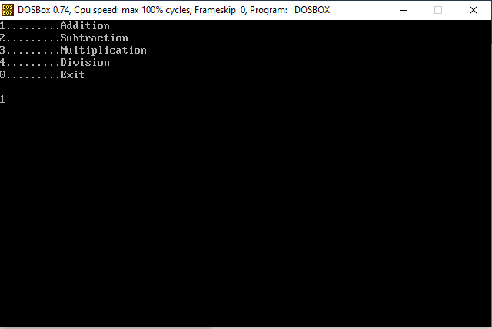

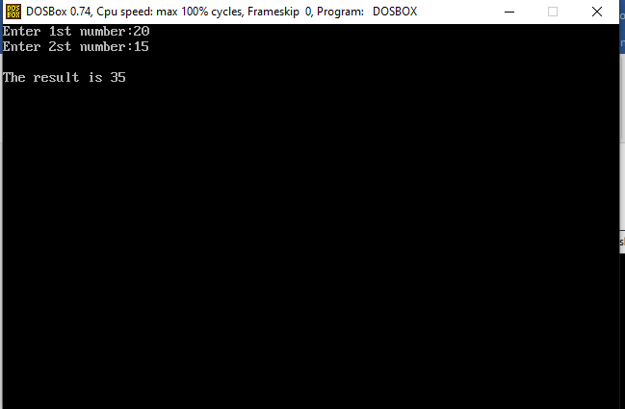

**Matrix Multiplication**

|  |  |  |  |  |  |  |  |
| --- | --- | --- | --- | --- | --- | --- | --- |
| **Test Scenario ID** | Even Odd-1 | Test Case ID | Even-Odd 1A | | | | |
| **Test Case Description** | Even-Odd Using Do -while | Test Priority | High | | | | |
| **Pre-Requisite** | Checks whether number is even or odd | Post-Requisite | NA | | | | |
|  |  |  |  |  | |  |  |
| S.No | Action | Expected Output | Actual Output | | Test Result | | |
| 1 | Matrix 1 rows and cols = 3 3  Matrix 2 rows and cols= 3 3 | 3 3 3  3 3 3  3 3 3 | 3 3 3  3 3 3  3 3 3 | | Pass | | |
| 2 | Matrix 1 rows and cols = 2 2    Matrix 2 rows and cols= 3 2 | Operation cannot be perform as no of cols are not equal to no of rows | Operation cannot be perform as no of cols are not equal to no of rows | | Fail | | |
| 3 | Matrix 1 rows and cols = 2 2  12345 234567  123145 312314  Matrix 2 rows and cols= 2 2 | Value exceeding the limit | Garbage Value | | Fail | | |

**Input**

#include<stdio.h>

#define MAX 50

int main()

{

int a[MAX] [MAX],b[MAX] [MAX],product[MAX] [MAX];

int arows,acolumns,brows,bcolumns;

int i,j,k;

int sum=0;

printf("Enter rows and columns of matrix:");

scanf("%d %d",&arows,&acolumns);

printf("Enter elements of matrix a:");

for(i=0;i<arows;i++)

{

for(j=0;j<acolumns;j++)

{

scanf("%d",&a[i][j]);

}

}

printf("Enter no of rows and columns of matrix b:");

scanf("%d %d",&brows,&bcolumns);

if(brows != acolumns)

{

printf("Sorry! We cannot multiply matrices a nd b");

}

else

{

printf("Enter elements of matrix b: \n");

for(i=0;i<brows;i++)

{

for(j=0;j<bcolumns;j++)

{

scanf("%d", &b[i][j]);

}

}

}

printf("\n");

for(i=0;i<arows;i++)

{

for(j=0;j<bcolumns;j++)

{

for(k=0;k<brows;k++)

{

sum+=a[i][k] * b[k][k];

}

product[i][j]=sum;

sum=0;

}

}

printf("Resultant Matrix\n");

for(i=0;i<arows;i++)

{

for(j=0;j<bcolumns;j++)

{

printf("%d",product[i][j]);

}

printf("\n");

}

return 0;

}

**Output**

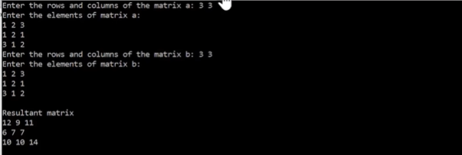

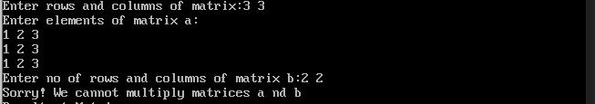

* **Causes for Matrix Multiplication Failure**
* When the number of rows is not equal to number of columns
* When first matrix`s row number is not  
  equal to second matrix`s columns number
* When the matrix value exceeds the range.